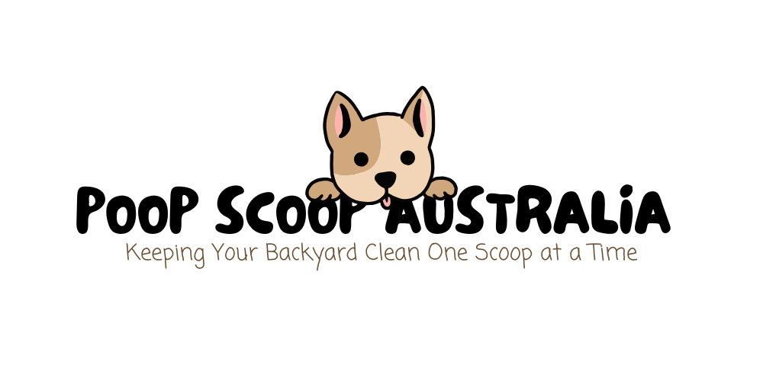

Please fill out the following form, answering all questions. Once completed email a copy to brendanmarkey@poopscoopaustralia.com to be eligible for a free cleanup.

Name:
………………………………………………………………………………………………………………………..

Email:
……………………………………………………………………………………………………………………

Phone Number:
……………………………………………………………………………………………………………………

Address
……………………………………………………………………………………………………………………

Your age:
…………………………………………….

Gender:
Male / Female / Other

Relationship Status:
Single / Married / Engaged / Other

No. of Kids:
0 / 1 / 2 / 3 / 4 / 5+

Number of Dogs:
1 / 2 / 3 / 4 / 5+

How often do you clean up the garden after your dog?
………………………………………………………………………………………………………………………

What do you find most frustrating about cleaning up dog waste?
………………………………………………………………………………………………………………………………………………………………………………………………………………………………………………

Have you ever considered hiring a dog poop removal service?
Yes / No

If not, why? (Too expensive, prefer to do it myself, never thought about it, etc.)
………………………………………………………………………………………………………………………………………………………………………………………………………………………………………………………………………………………………………………………………………………………………………

How often would you want the service?
Bi-Weekly / Weekly / Fortnightly / Monthly / Other
If other, please specify: ………………………………………………………………………………………

How much would you be willing to pay for a weekly dog poop removal service?
………………………………………………………………………………………………………………………

What would make you consider using such a service?
………………………………………………………………………………………………………………………………………………………………………………………………………………………………………………………………………………………………………………………………………………………………………

Would you prefer a scheduled service or an on-demand option?
………………………………………………………………………………………………………………………………………………………………………………………………………………………………………………………………………………………………………………………………………………………………………

Where does your dog usually go to the bathroom? (Backyard, Front yard, Public areas, Other)
………………………………………………………………………………………………………………………………………………………………………………………………………………………………………………………………………………………………………………………………………………………………………

Would you be interested in additional services, such as deodorizing or sanitizing the area?
………………………………………………………………………………………………………………………………………………………………………………………………………………………………………………………………………………………………………………………………………………………………………

How would you prefer to learn about a service like this? (Social media, Flyers, Word of mouth, Website, Local pet stores)
………………………………………………………………………………………………………………………………………………………………………………………………………………………………………………………………………………………………………………………………………………………………………

What factors would influence your decision to choose one dog waste removal service over another? (Price, reliability, eco-friendly disposal, customer reviews, etc.)
………………………………………………………………………………………………………………………………………………………………………………………………………………………………………………………………………………………………………………………………………………………………………

Do you have any concerns about using a dog poop removal service?
………………………………………………………………………………………………………………………………………………………………………………………………………………………………………………………………………………………………………………………………………………………………………

What would make this service a “must-have” for you?
………………………………………………………………………………………………………………………………………………………………………………………………………………………………………………………………………………………………………………………………………………………………………

Any other thoughts or suggestions?
………………………………………………………………………………………………………………………………………………………………………………………………………………………………………………………………………………………………………………………………………………………………………

Ultimately, why would/wouldn’t you purchase this service?
………………………………………………………………………………………………………………………………………………………………………………………………………………………………………………………………………………………………………………………………………………………………………

